Cantonese cuisine

**Cantonese cuisine**, also known as **Yue cuisine**(粵菜) or **Guangdong cuisine**, refers to the cuisine of China's [Guangdong Province](https://en.wikipedia.org/wiki/Guangdong), particularly the provincial capital, [Guangzhou (Canton)](https://en.wikipedia.org/wiki/Guangzhou). It is one of the Eight Culinary Traditions of [Chinese cuisine](https://en.wikipedia.org/wiki/Chinese_cuisine). Its prominence outside China is due to the large number of [Cantonese](https://en.wikipedia.org/wiki/Cantonese_people) [emigrants](https://en.wikipedia.org/wiki/Overseas_Chinese). Chefs trained in Cantonese cuisine are highly sought after throughout China. Formerly, most Chinese restaurants in the West served largely Cantonese dishes. Guangzhou (Canton) City, the provincial capital of Guangdong and the center of Cantonese culture, has long been a trading hub and many imported foods and ingredients are used in Cantonese cuisine. Besides pork, beef and chicken, Cantonese cuisine incorporates almost all edible meats, including offal, chicken feet, duck's tongue, frog legs, snakes and snails. However, lamb and goat are less commonly used than in the cuisines of northern or western China. Many cooking methods are used, with steaming and stir frying being the most favoured due to their convenience and rapidity. Other techniques include shallow frying, double steaming, braising and deep frying.

For many traditional Cantonese cooks, the flavours of a dish should be well balanced and not greasy. Apart from that, spices should be used in modest amounts to avoid overwhelming the flavours of the primary ingredients, and these ingredients in turn should be at the peak of their freshness and quality.

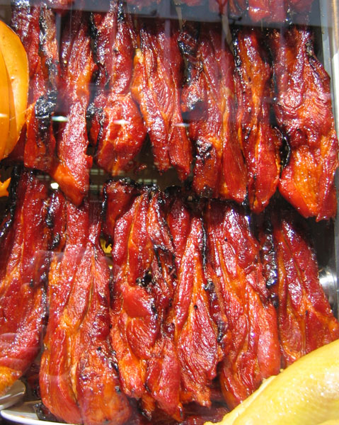

***Char siu*** is a popular way to flavor and prepare [barbecued](https://en.wikipedia.org/wiki/Barbecue) [pork](https://en.wikipedia.org/wiki/Pork) in [Cantonese cuisine](https://en.wikipedia.org/wiki/Cantonese_cuisine). It is classified as a type of *[siu mei](https://en.wikipedia.org/wiki/Siu_mei" \o "Siu mei)*, Cantonese roasted meat.

### Claypot_Chicken_Rice,_Singapore

Little pot rice are dishes cooked and served in a flat-bottomed pot (as opposed to a round-bottomed [wok](https://en.wikipedia.org/wiki/Wok)). Usually this is a [saucepan](https://en.wikipedia.org/wiki/Saucepan) or [braising](https://en.wikipedia.org/wiki/Braising) pan (see [clay pot cooking](https://en.wikipedia.org/wiki/Clay_pot_cooking)). Such dishes are cooked by covering and steaming, making the rice and ingredients very hot and soft. Usually the ingredients are layered on top of the rice with little or no mixing in between. Many standard combinations exist.

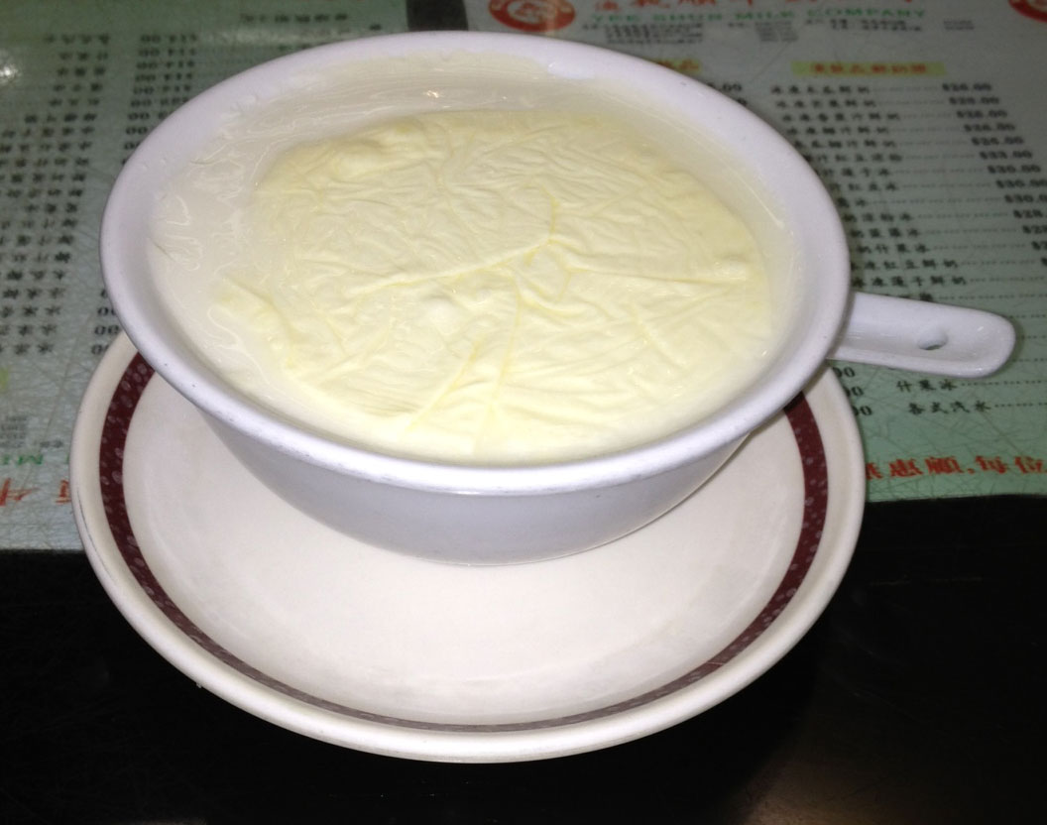

**Double skin milk** is a Cantonese dessert made of milk, egg whites, and sugar. It was first invented in Shunde, Guangdong. It is a velvety smooth milk custard somewhat resembling panna cotta, with two skins. The first skin is formed during cooling of the boiled milk and the second when cooling the cooked custard. Traditionally buffalo milk is used; its higher fat content compared to cow's milk produces a smooth texture. This dessert is particularly famous in [Shunde](https://en.wikipedia.org/wiki/Shunde" \o "Shunde), [Guangzhou](https://en.wikipedia.org/wiki/Guangzhou), [Macau](https://en.wikipedia.org/wiki/Macau), and [Hong Kong](https://en.wikipedia.org/wiki/Hong_Kong).

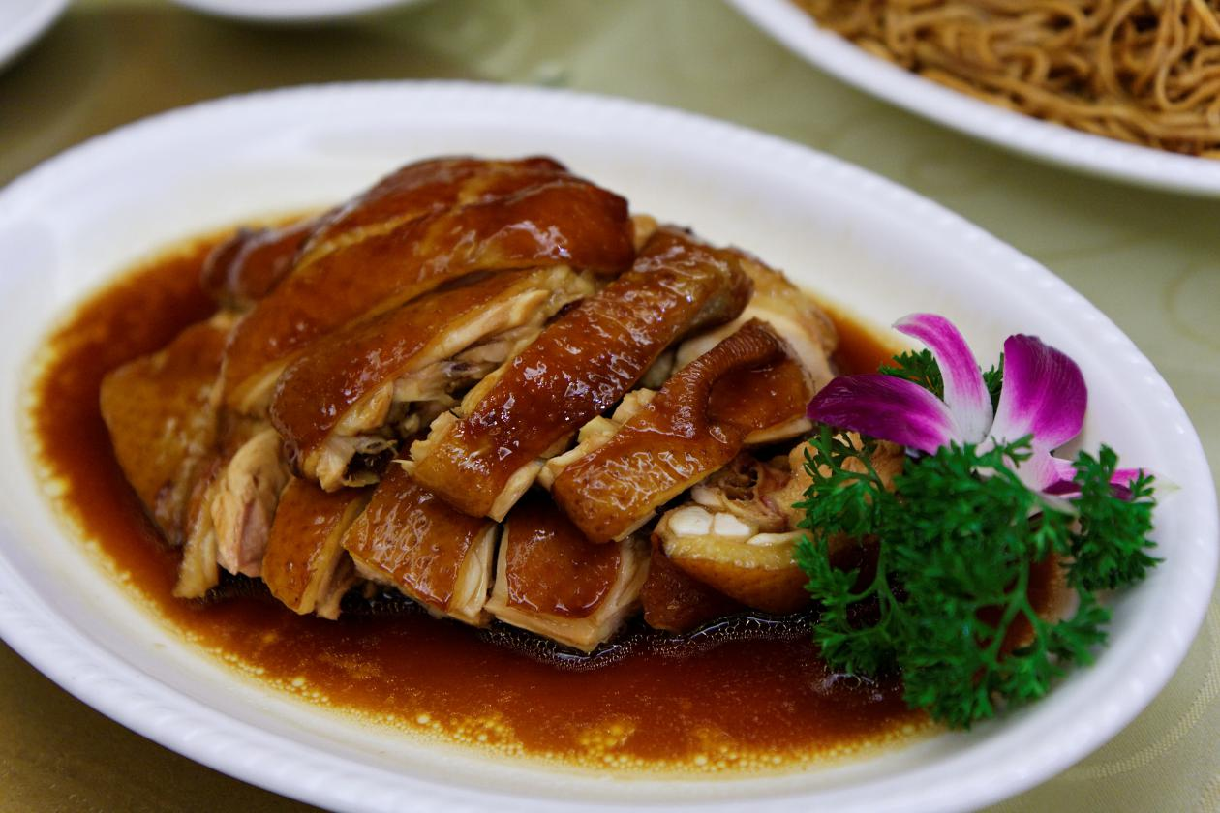

**Soy sauce chicken** is a traditional [Cantonese cuisine](https://en.wikipedia.org/wiki/Cantonese_cuisine) dish made of chicken cooked with [soy sauce](https://en.wikipedia.org/wiki/Soy_sauce). It is considered as a [siu mei](https://en.wikipedia.org/wiki/Siu_mei" \o "Siu mei) dish in [Hong Kong](https://en.wikipedia.org/wiki/Hong_Kong).

The strong flavour of soy sauce usually covers up the taste of chicken. Another Cantonese dish [white cut chicken](https://en.wikipedia.org/wiki/White_cut_chicken), often served with soy sauce dip, is more savoured for the taste of the meat, where the freshness of the chicken is noticeable.

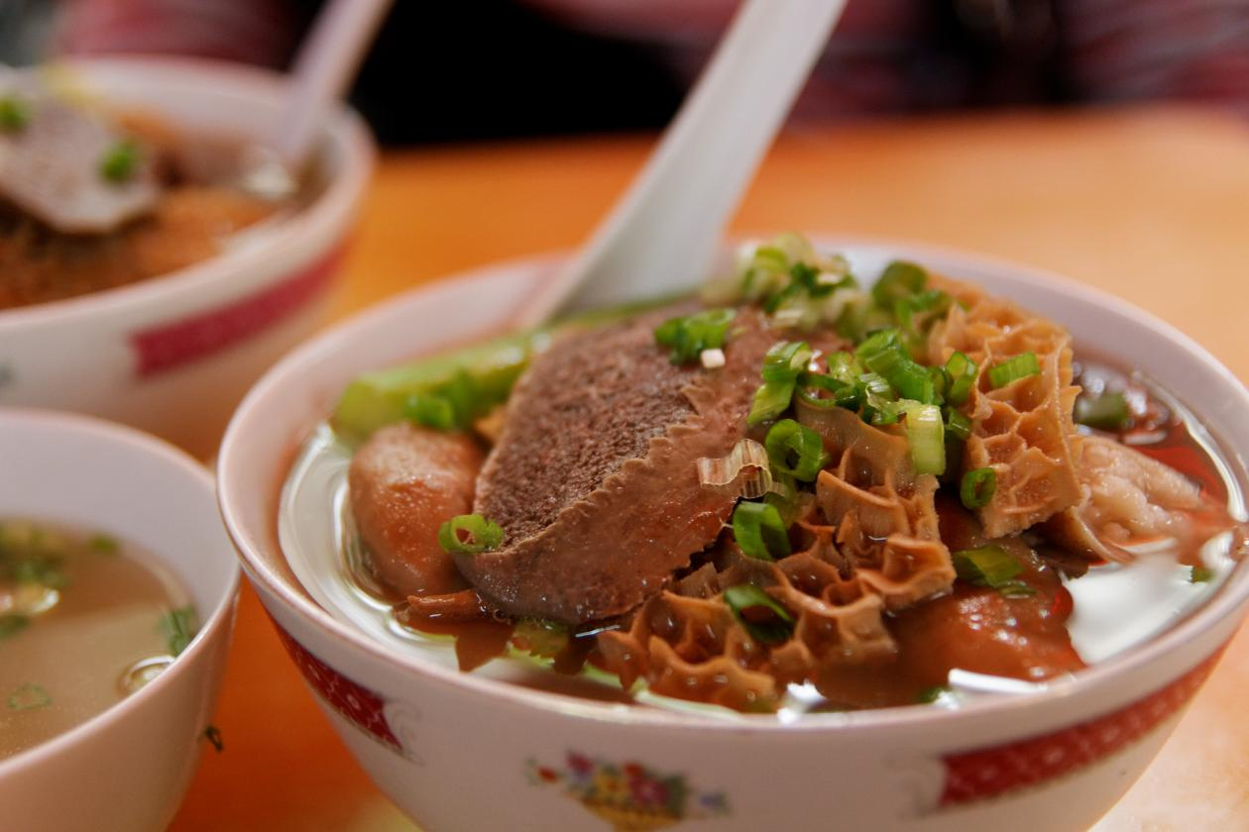

**Beef entrails** is a [Hong Kong dish](https://en.wikipedia.org/wiki/Hong_Kong_cuisine) largely influenced by [Cantonese cuisine](https://en.wikipedia.org/wiki/Cantonese_cuisine).

Good quality beef is chosen to stew with its entrails for a couple of hours. There are several ways to serve this food, for instance, as beef entrails [hot pot](https://en.wikipedia.org/wiki/Hot_pot), beef entrails on a [skewer](https://en.wikipedia.org/wiki/Skewer) and beef entrails served with pieces etc. The seasonings called "13 herbs" are the main composition of the [master stock](https://en.wikipedia.org/wiki/Master_stock) sauce. None of the herbs can be omitted, or else it causes a huge change of flavour. The herbs are [fennel](https://en.wikipedia.org/wiki/Fennel), [Sichuan peppercorn](https://en.wikipedia.org/wiki/Sichuan_peppercorn), [star anise](https://en.wikipedia.org/wiki/Star_anise), dried [citrus peel](https://en.wikipedia.org/wiki/Citrus_peel), [cinnamon](https://en.wikipedia.org/wiki/Cinnamon), [sand ginger](https://en.wikipedia.org/wiki/Sand_ginger), and [nutmeg](https://en.wikipedia.org/wiki/Nutmeg). The [tripe](https://en.wikipedia.org/wiki/Tripe) (four tripes of the cow are edible but the [honeycomb](https://en.wikipedia.org/wiki/Honeycomb" \o "Honeycomb)tripe has the highest rating), pancreas, intestine, spleen and lungs are the major characters of the beef entrails. The dish is usually served with [chili oil](https://en.wikipedia.org/wiki/Chili_oil) and [black pepper](https://en.wikipedia.org/wiki/Black_pepper).

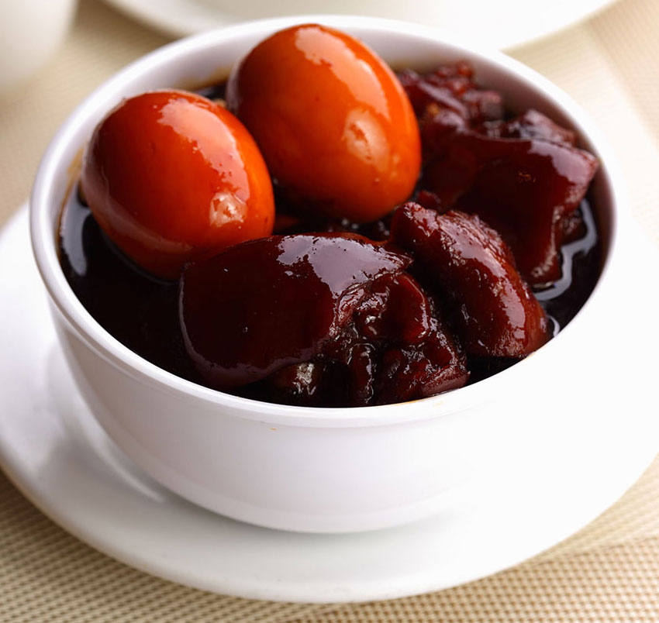

介绍：Pork Knuckles and Ginger Stew is a dish in traditional Cantonese cuisine. It is traditionally eaten by new mothers in Guangzhou to restore strength and health, and is presented to friends and family to indicate the arrival of a new baby.

传说故事：According to legend in the early Ming Dynasty there lived a butcher who had the good fortune to marry a very pretty, kind and gumptious girl. However, their happiness was broken by the fact that even after several years of marriage, the wife was still without child. Now in traditional Chinese feudalism, there are three unfilial sins, and of these failure to bear a descendant to carry the family name is by far the most unforgivable. Therefore, the butcher’s mother forced the two to divorce.

The wife was heartbroken, leaving the family home she moved to a hut on a hill. However to her own surprise she found that she was now pregnant.

The butcher still loved his wife and visited her. When he received the news of her pregnancy, he was afraid that his wife and the newborn would be malnourished, so he brought her some unsold pork knuckles and stewed them in sweet black vinegar in a big pot together with ginger and eggs.

After several years, the child finally grew up. The wife forgave the butcher’s mother and returned with her son to the marital home and asked her son to take with him a pot of sweet vinegar stew as a gift for his grandmother. His grandmother was elated to receive him and the stew.

Thereafter, whenever a baby is born, the family will make a pot of sweet vinegar stew and share it with friends and neighbors.